Eucharisto:
A thanksgiving journal.

Come, let us sing for joy to the Lord;
let us shout aloud to the Rock of our salvation.
Let us come before him with thanksgiving
and extol him with music and song.
Psalm 95:1-2
The words Eucharisto means I am thankful. Psalm 106, like many of the Psalms, encourages us to give thanks - give thanks to the Lord, his love endures forever. When Jesus takes bread, as in Luke 22, he gives thanks and then he breaks it. The apostle Paul encourages us to give thanks in all circumstances. Yet giving thanks is sometimes easier said than done. After Jesus healed the ten people with leprosy, only one came back and gave thanks. Thanksgiving is a bit like forgiveness. It benefits the person giving thanks as well as the one receiving it. The more thankfulness becomes part of our lives, the more we become thankful people. Thankfulness is life-giving and, while thanksgiving can be directed towards others, it is ultimately also directed towards God.

Habits of the heart, like thanksgiving, take practice. Johnson Oatman in his 1987 hymn encourages us to count our blessings and to name them one by one.Maybe over the next month you might like to try doing this by using this thanksgiving journal. Each day note down ten blessings, ten things to give thanks for. Some ideas and prompts are given on the next page. You also might like to add images and poems and bible passages to this booklet to remind you of the things you give thanks for.

In the Prayer Book there is a prayer of General Thanksgiving. While the language is old it does direct our hearts to thanks:

ALMIGHTY God, Father of all mercies, we thine unworthy servants do give thee most humble and hearty thanks for all thy goodness and loving-kindness to us and to all men; [*particularly to those who desire now to offer up their praises and thanksgivings for thy late mercies vouchsafed unto them.] We bless thee for our creation, preservation, and all the blessings of this life; but above all for thine inestimable love in the redemption of the world by our Lord Jesus Christ, for the means of grace, and for the hope of glory. And we beseech thee, give us that due sense of all thy mercies, that our hearts may be unfeignedly thankful, and that we shew forth thy praise, not only with our lips, but in our lives; by giving up ourselves to thy service, and by walking before thee in holiness and righteousness all our days; through Jesus Christ our Lord, to whom with thee and the Holy Ghost be all honour and glory, world without end. Amen.
Thanksgiving prompts

- What are you thankful for that you did not have last year?
- What memory do you want to give thanks for?
- What piece of music or poem do you want to give thanks for?
- What artist or musician do you want to give thanks for?
- What is it about your body you want to give thanks for?
- What is it about your health you want to give thanks for?
- What bit of technology do you want to give thanks for?
- What photograph do you want to give thanks for?
- What conversation do you want to give thanks for?
- What make of chocolate do you want to give thanks for?
- What accomplishment do you want to give thanks for?
- What item of clothing do you want to give thanks for?
- What friendship do you want to give thanks for?
- What Psalm do you want to give thanks for?
- What family member do you want to give thanks for?
- What teacher do you want to give thanks for?
- What plant in the garden do you want to give thanks for?
- What bird or tree do you want to give thanks for?
- What time of day do you want to give thanks for?
- What mistake do you want to give thanks for?
- What time of adversity do you want to give thanks for?
- What holiday do you want to give thanks for?
- What group of people do you want to give thanks for?
- What part of creation do you want to give thanks for?
- What promise of God do you want to give thanks for?
- What place have you been to that you want to give thanks for?
- Look around the room you are in - what are you thankful for?
- Look out the window - what are you thankful for?
- Think about the presence of God in your life - what are you thankful for?
- Think about the presence of God in the world- what are you thankful for?
- Look back over the last 24 hours - what are you thankful for?
- Look at your diary over the last week -what are you thankful for?
- Look to the coming week - what are you thankful for?

Eucharisto: I am thankful
Day 1: .

Eucharisto: I am thankful
Day 2: .

Eucharisto: I am thankful
Day 3: .
Eucharisto: I am thankful
Day 4: .
Eucharisto: I am thankful
Day 5: .
Eucharisto: I am thankful
Day 6: .
Eucharisto: I am thankful
Day 7: .
Eucharisto: I am thankful
Day 8: .
Eucharisto: I am thankful
Day 9: .

Eucharisto: I am thankful
Day 10: .
Eucharisto: I am thankful
Day 11: .
Eucharisto: I am thankful
Day 12: .
Eucharisto: I am thankful
Day 13: .
Eucharisto: I am thankful
Day 14: .
Eucharisto: I am thankful
Day 15: .
Eucharisto: I am thankful
Day 16: .
Eucharisto: I am thankful
Day 17: .
Eucharisto: I am thankful
Day 18: .
Eucharisto: I am thankful
Day 19: .
Eucharisto: I am thankful
Day 20: .
Eucharisto: I am thankful
Day 21: .
Eucharisto: I am thankful
Day 22: .
Eucharisto: I am thankful
Day 23: .
Eucharisto: I am thankful
Day 24: .
Eucharisto: I am thankful
Day 25: .
Eucharisto: I am thankful
Day 26: .
Eucharisto: I am thankful
Day 27: .
Eucharisto: I am thankful
Day 28: .
Eucharisto: I am thankful
Day 29: .
Eucharisto: I am thankful
Day 30: .
Eucharisto: I am thankful
Day 31: .

Eucharisto:
A thanksgiving journal.

Come, let us sing for joy to the Lord;
let us shout aloud to the Rock of our salvation.
Let us come before him with thanksgiving
and extol him with music and song.
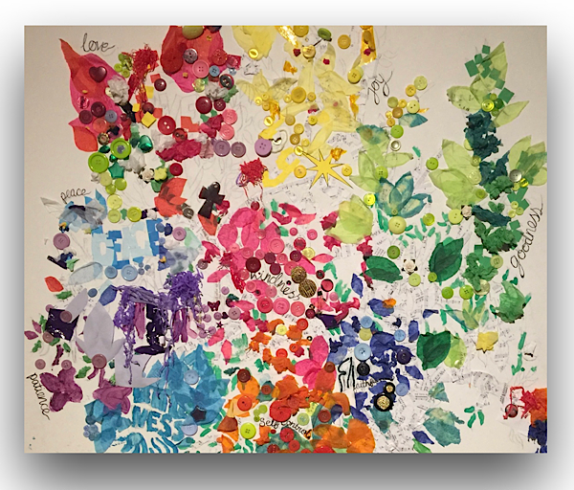
Psalm 95:1

The Prayer Room 2021

